#### **Creating and Working with Two Branches in VS Code and AWS CodeCommit**



#### **Objective:**

This guide will walk you through the process of creating two branches in a Git repository, working with them in Visual Studio Code (VS Code), and using AWS CodeCommit to manage your changes.

#### **Prerequisites:**

* Visual Studio Code (VS Code) installed.
* Git installed on your local machine.
* [https://github.com/git-for-windows/git/releases/download/v2.46.0.windows.1/Git-2.46.0-64-bit.ex](https://github.com/git-for-windows/git/releases/download/v2.46.0.windows.1/Git-2.46.0-64-bit.exe)e
* AWS CLI configured with access to your AWS account.
* https://awscli.amazonaws.com/AWSCLIV2.msi
* A repository created in AWS CodeCommit.

### **Steps:**

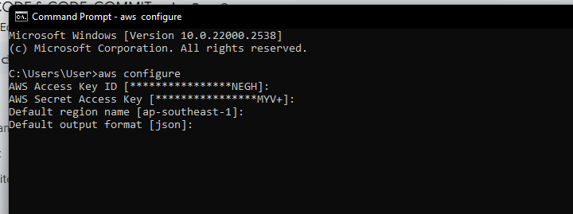

#### **1. Clone the AWS CodeCommit Repository in VS Code**

* Open VS Code.
* Open the terminal in VS Code by pressing Ctrl + `` (backtick) or going to View>Terminal`.

**git clone https://git-codecommit.<region>.amazonaws.com/v1/repos/<repository-name>**

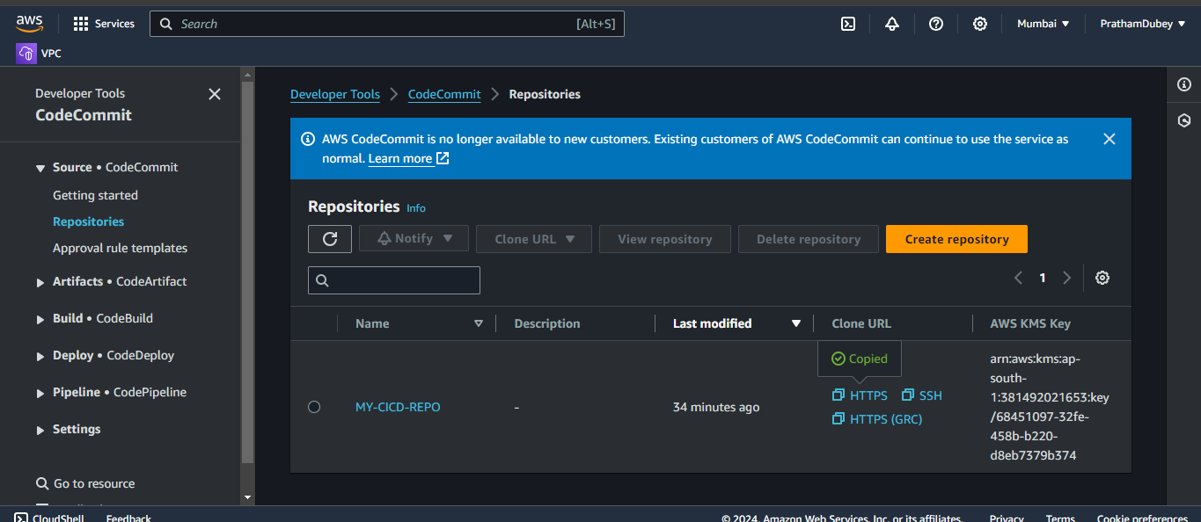

#### 

#### **2. Create the First Branch**

Navigate to the repository directory:

cd <repository-name>

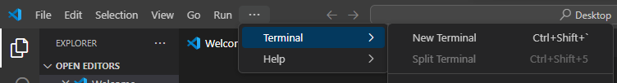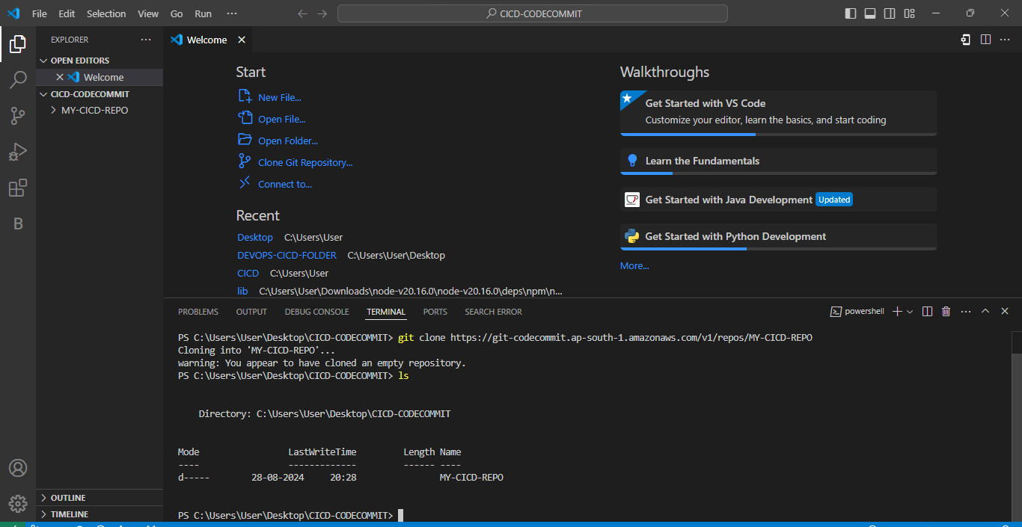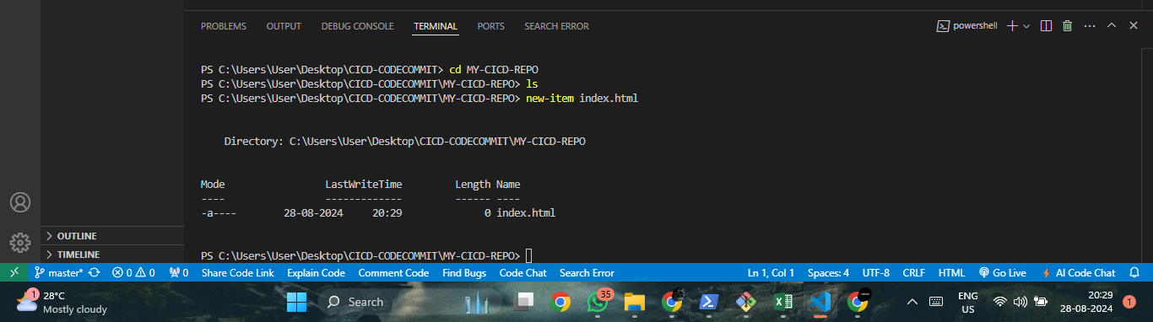**current working branch**

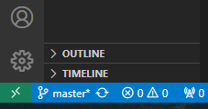

! ENTER CREATES TEMPLATE FOR YOUR HTML FILE 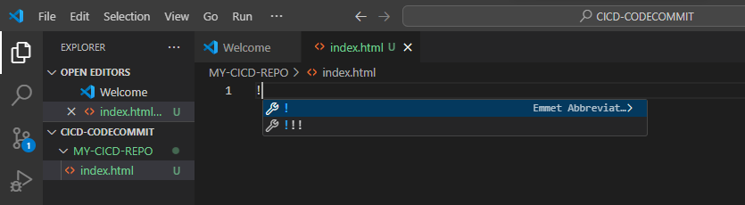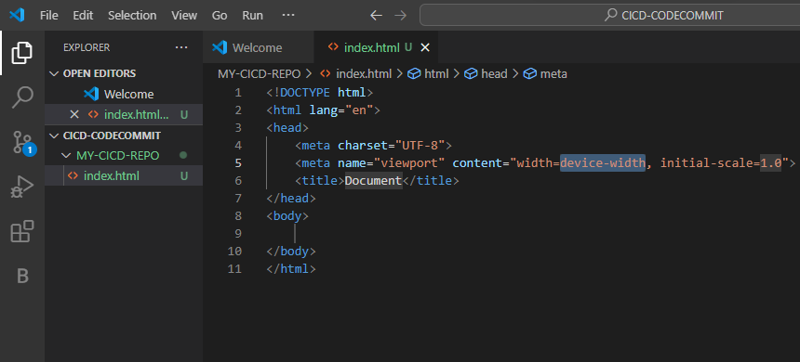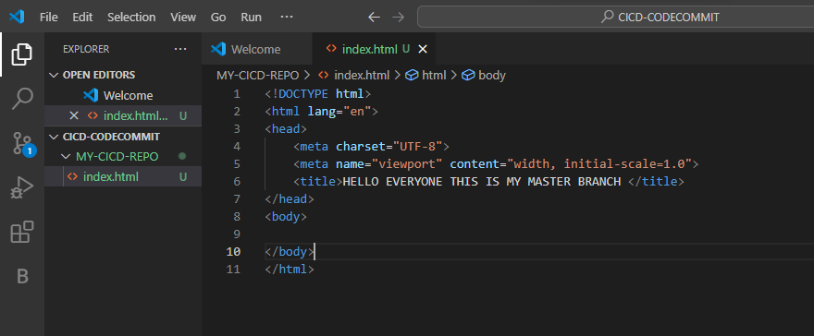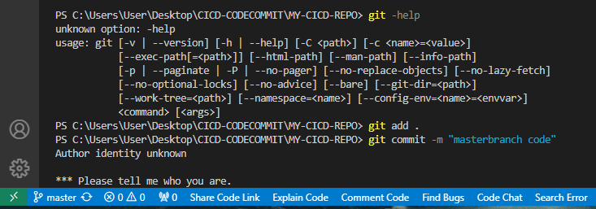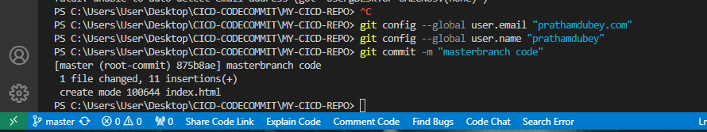

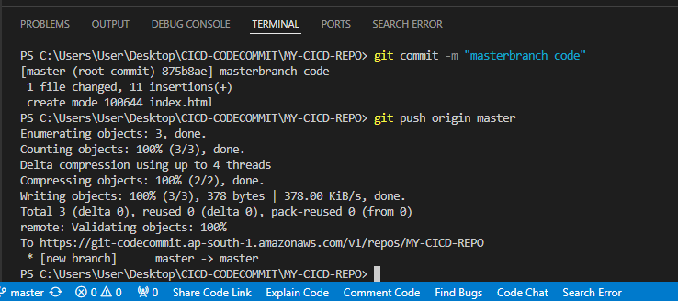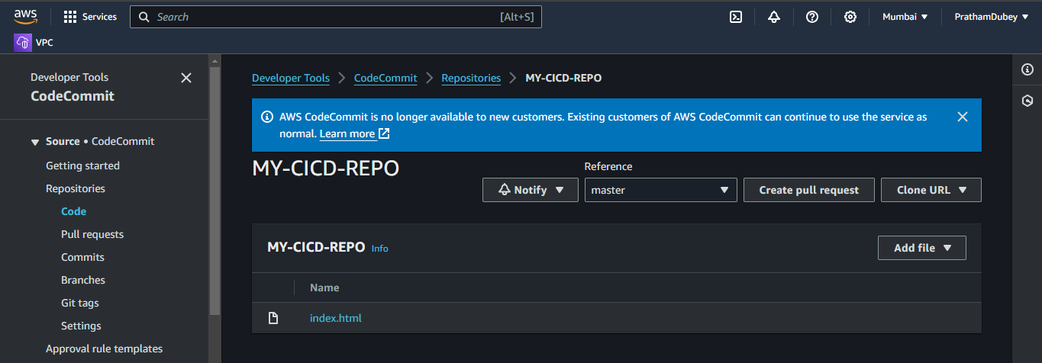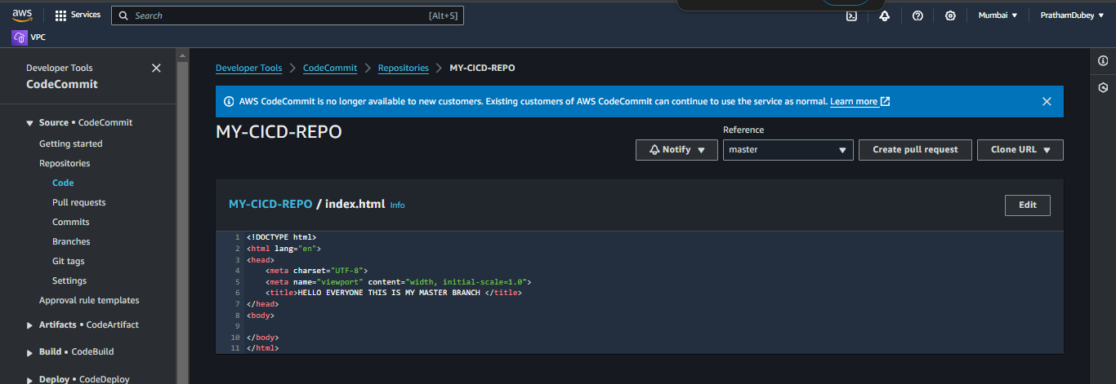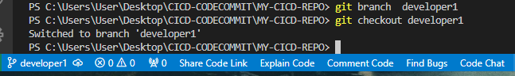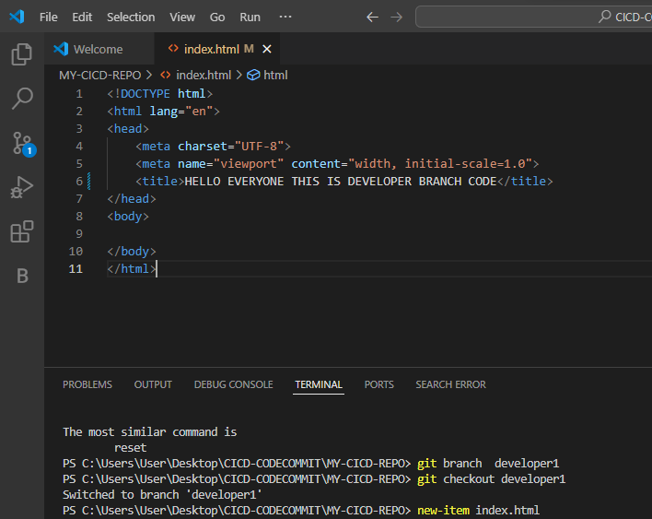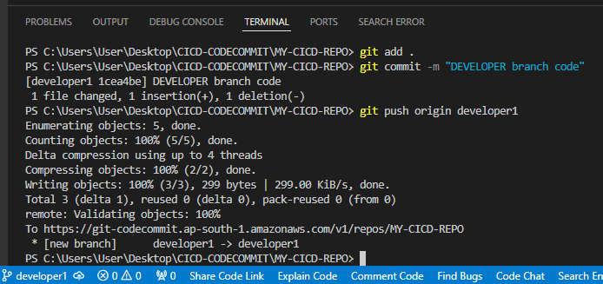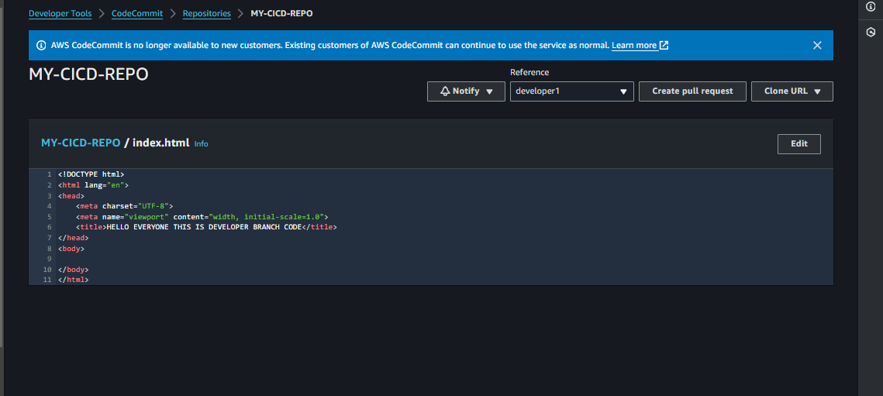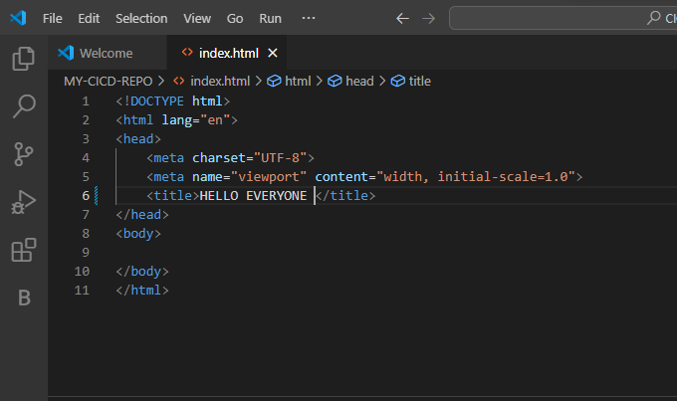

Create a new branch (e.g., developer1) and switch to it:  
git checkout



* The branch is now created and you are working on developer1.

#### **3. Make Changes and Commit to the First Branch**

* In VS Code, make the necessary changes to your files.
* Save your changes (Ctrl + S).

Stage the changes:

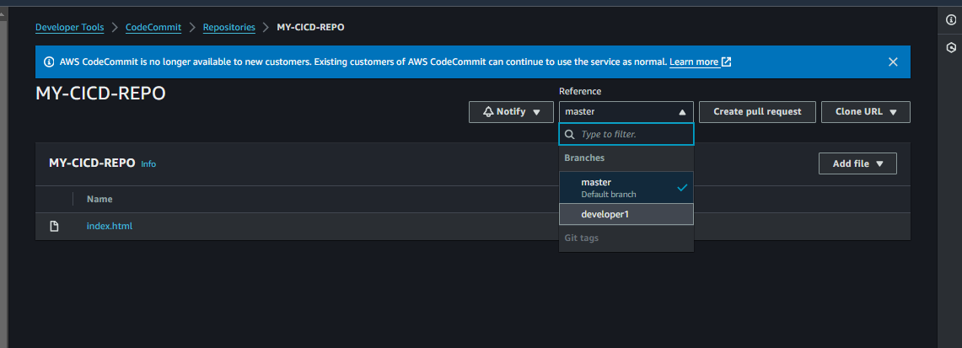

git add .

git commit -m "Add changes in developer1"



#### **4. Push the First Branch to AWS CodeCommit**

Push the branch to AWS CodeCommit:  
  
git push origin developer1





#### **5. Create the Second Branch**

Switch to the master branch:  
  
git checkout master

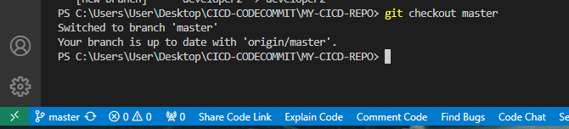

#### **6. Make Changes and Commit to the Second Branch**

* In VS Code, make different changes for the second feature.
* Save your changes (Ctrl + S).

Stage the changes:

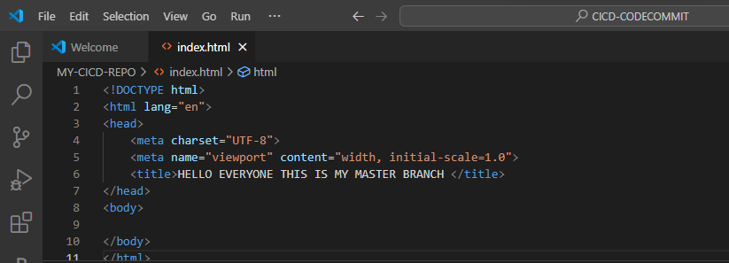  
  
git add .  
git commit -m " developer2 code "

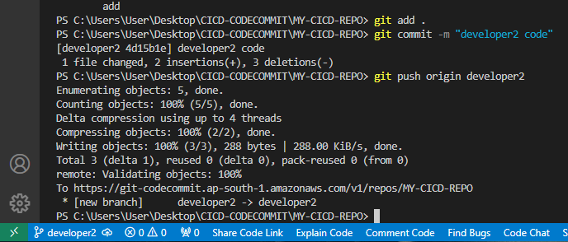

#### **7. Push the Second Branch to AWS CodeCommit**

Push the second branch to AWS CodeCommit:  
  
  
git push origin developer2

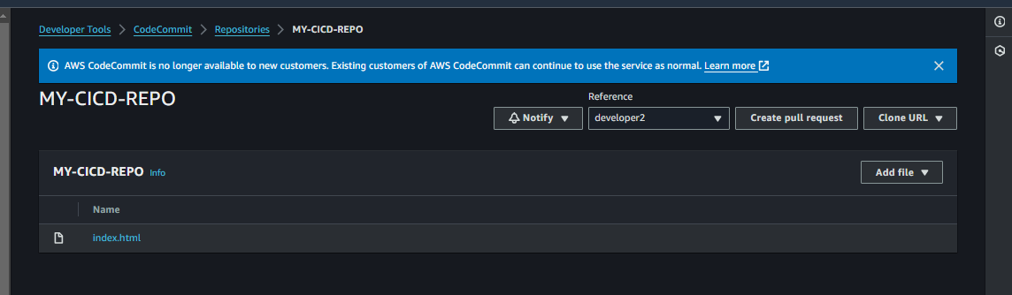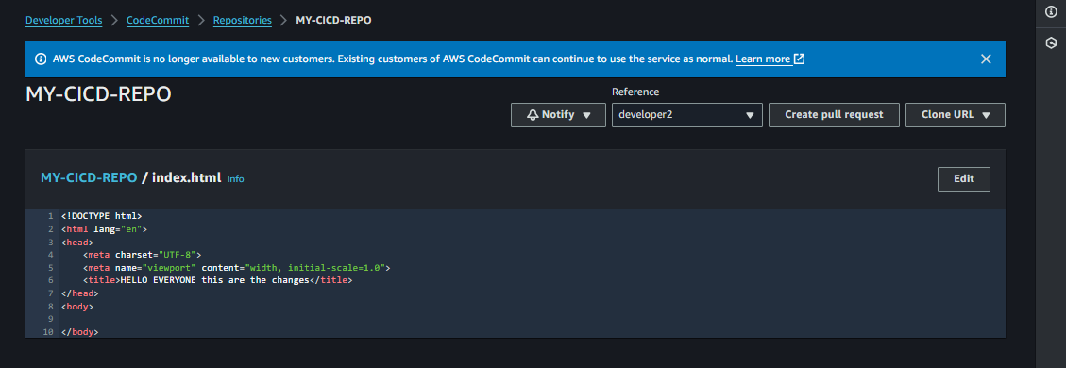

#### **8. Check the Current Working Branch**

* To verify the current branch in VS Code:
  + Look at the bottom left corner of the VS Code window. The current branch name is displayed in the status bar.

Alternatively, open the terminal in VS Code and run:  
  
  
git branch

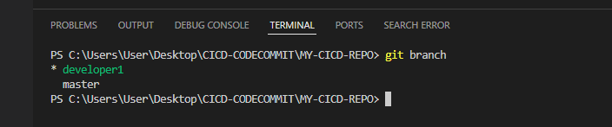

#### **9. Switch Between Branches**

To switch between the two branches:  
  
  
git checkout developer1

git checkout developer2

#### **10. Merge the Branches (Optional)**

If you want to merge developer1 into master:  
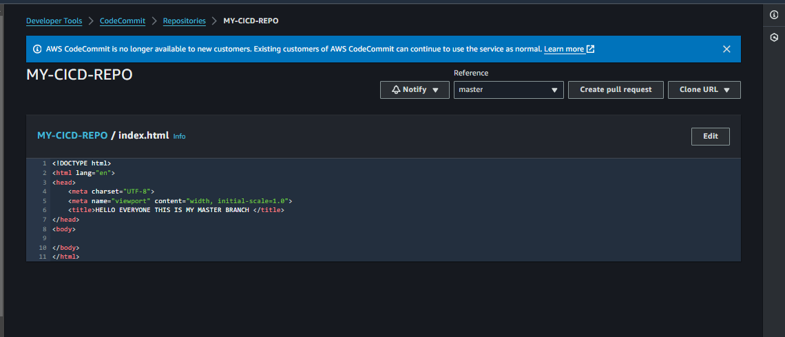  
git checkout master

git merge developer1

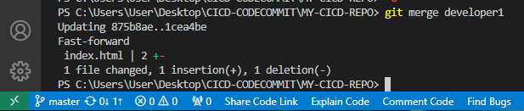

Push the changes to AWS CodeCommit:  
  
  
git push origin master

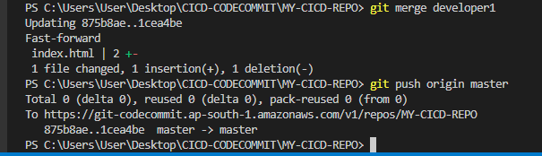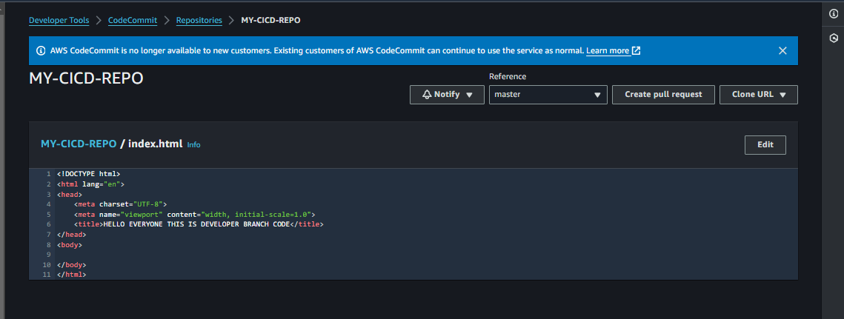

Git log

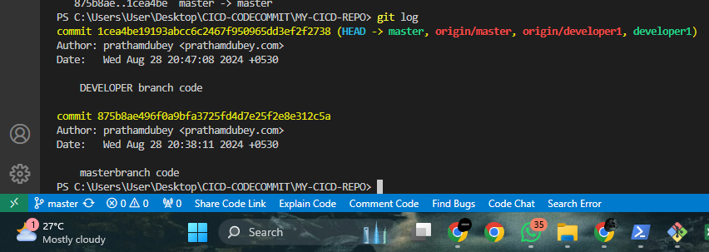

Git status

Git checkout master – index.html

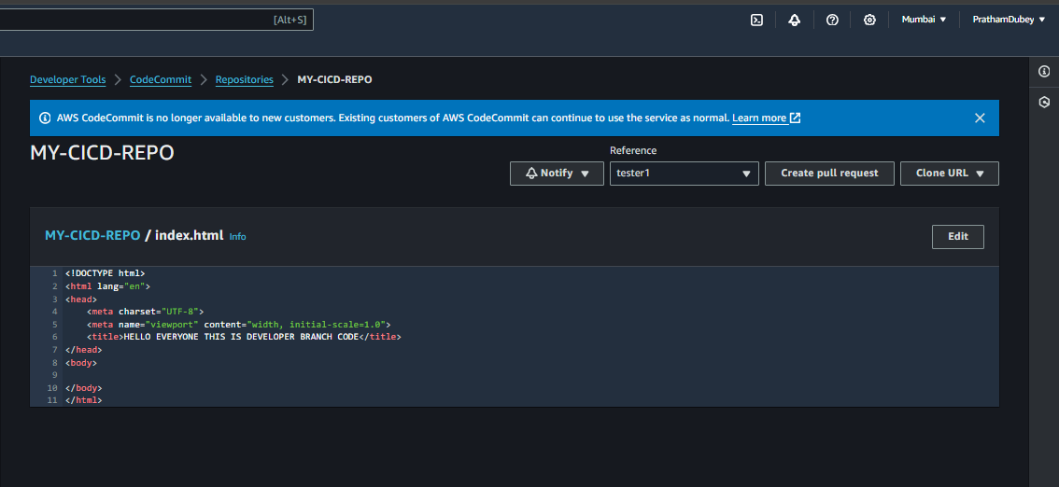Before

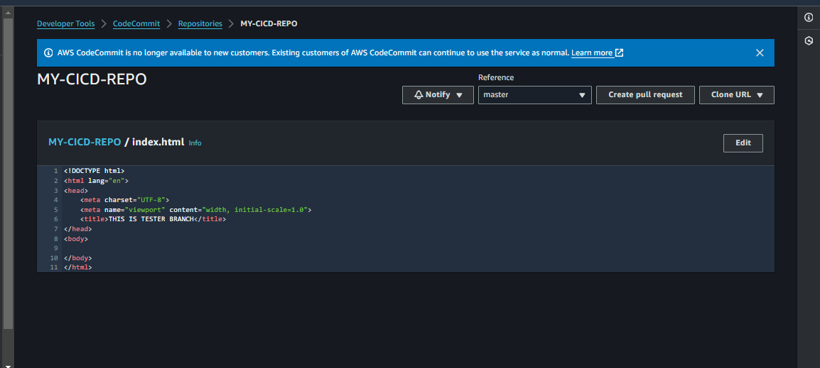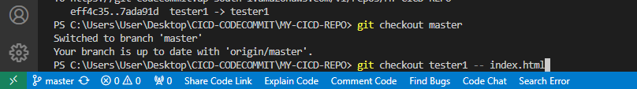

After

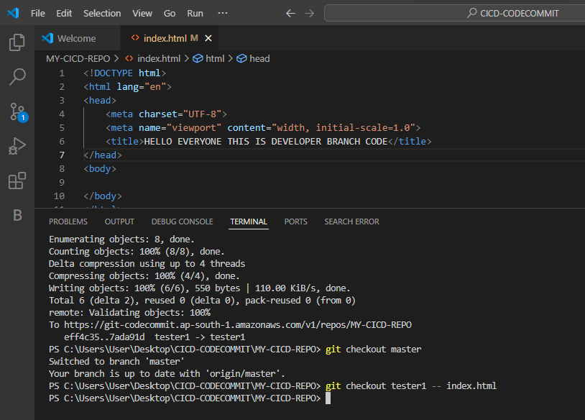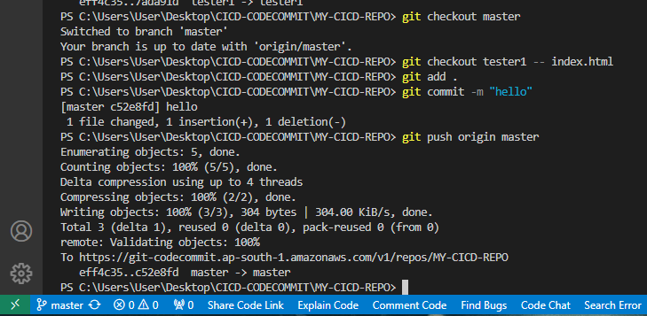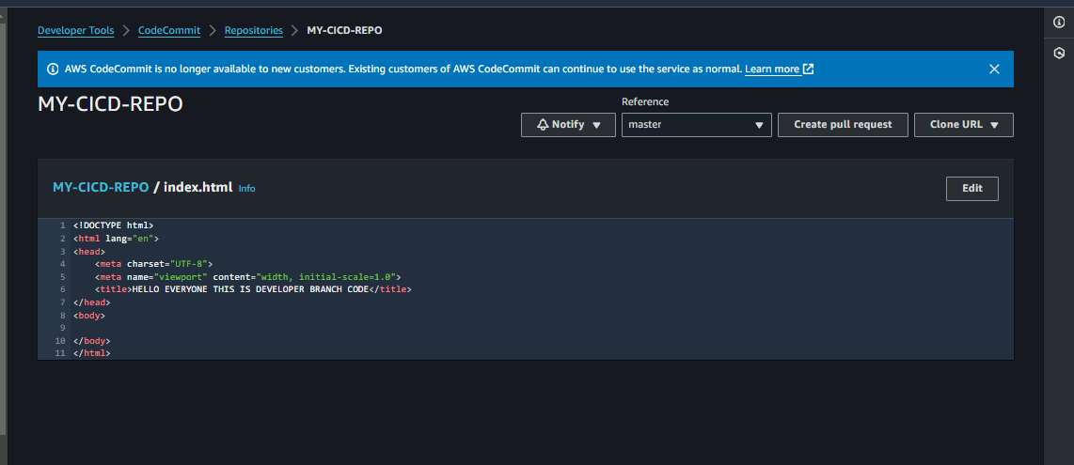

#### **Conclusion:**

By following this documentation, you can effectively create and work with multiple branches in VS Code while using AWS CodeCommit to manage and track your changes. This process enables better version control and collaborative development.